Calibrating new Microscopes
Required materials:
Slide with fluorescent beads for calculating bleed-through:
Link to our calibration slide
BARseq library preparation reagents and sequencing reagents.
Padlocks: Slc17a7-3probe panel: XC182,184, and 186
Sequencing primers: XC2820, 2821, 2822 and 2823

- Create calibration slides:
These slides have padlocks only for Slc17a7, and each chamber is hybridized with a unique sequencing primer. So that for each chamber, gene code for Slc17a7 will start on G, A, T or C respectively.
  - Follow excel sheet Microscope_Calibration_TEMPLATE to create library
  - Sequence first gene cycle
  - Seal the ports for long term storage (calibration slides can be stored in the fridge as long as they don’t dry out. Keep in dark chamber to minimize light exposure).

- Take an image from one FOV of each chamber of the calibration slides.
Each chamber corresponds to one nucleotide channel.
  - Check signals in all four channels and make a note of which chamber is which. (example labeling below).
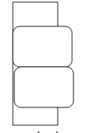

  - Select one FOV to image at relatively similar brain region and position in each chamber. (For each chamber, it should only have signals from one channel, except bleedthrough)
  - Save points list for image (4 fovs), and image using normal BARseq gene cycle imaging parameters. (e.g. run singlesubsequent-sc.xml).
  - Make a max projection with imagej (image to stack, z project with max intensity) of each channel, The combine the 4 max projection images into one tiff in the order of G,T,A,C (this is the same order as the analysis pipeline)
  - Save the combined max projection images into corresponding folders named “G_chamber”, “T_chamber”, “A_chamber”, “C_chamber” (keep the folder name in this way if you want to use Aixin’s script).

- Calculate optimal exposure times
Use optimal_exposure_time_calculator.xlsx to calculate optimal exposure time of each channel.
We want to get each channel’s signal intensity balanced, or gene decoding will be worse. Necessary to do this step first before proceeding to the channel shift and bleed-through step!

- For each calibration image, open max projection and navigate to the channel containing gene signals. Use ImageJ to select ~ 1000 reasonable rolonies (dots), you can use the ImageJ “Find Maxima” function.
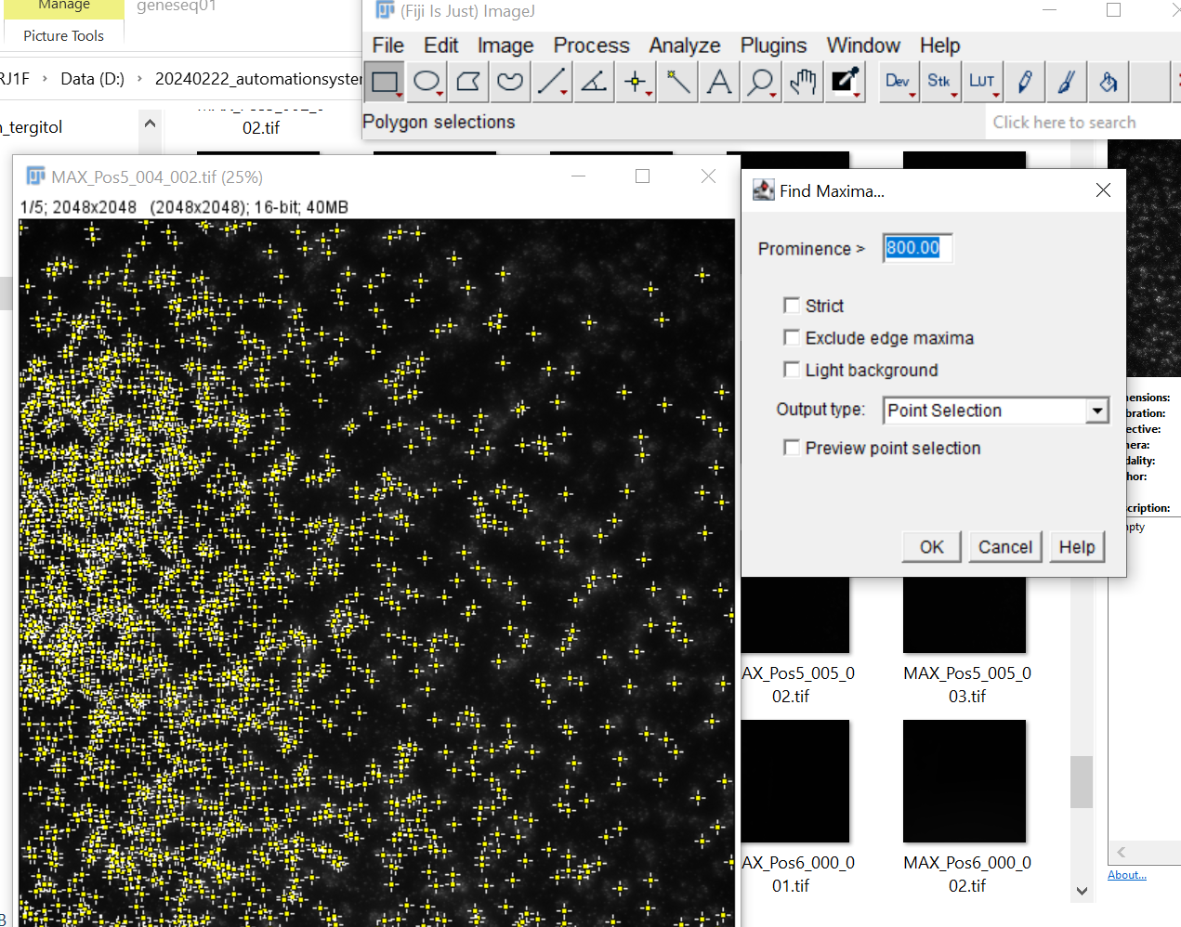

- Output Point Selection to get the signal intensity (mean) in ImageJ.
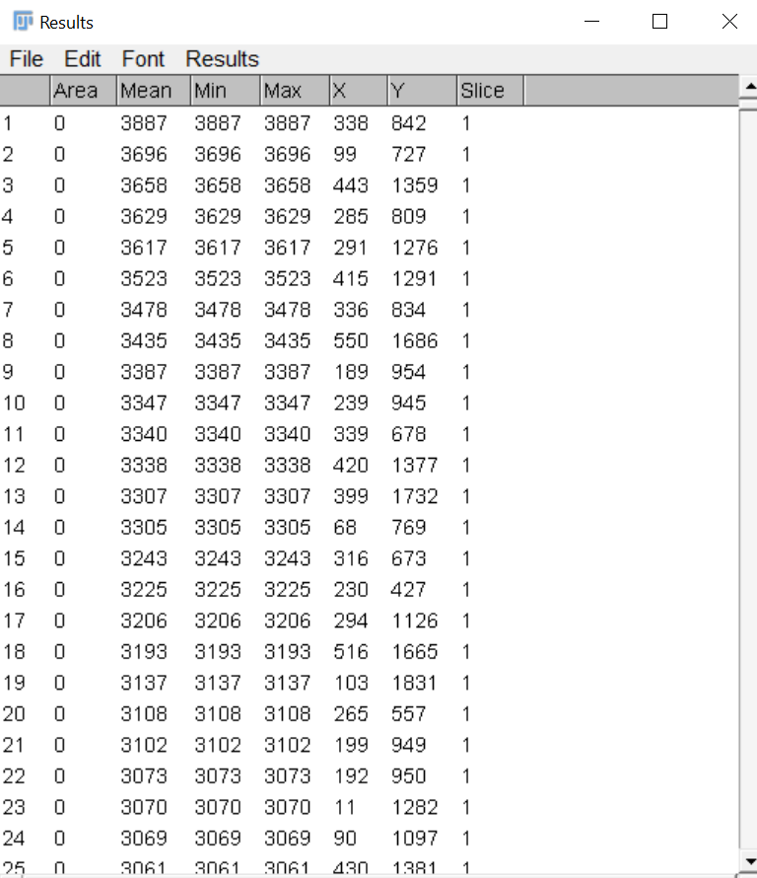
- copy mean signal intensity and xy location columns into optimal_exposure_time_calculator.xlsx “SI” column for the appropriate channel. Note: the balanced exposure time calculated by the signal intensity of G, so fill the G channel signal intensity first.
- Fill in the current channel exposure time you used in “current exposure” row
- The number in calibrated_exposure row is the suggested exposure time for each channel. Round to nearest possible microscope setting to decide final exposures.
- If exposure times change from the default, save optical configurations in Nikon for the new exposure times.
4. Calculate channel shift (chshift20x)
- Prepare or use a commercial fluorescent calibration slide. Choose a bead size that is similar to gene rolonies, ~200nm sized beads that are fluorescent in all imaging channels. For commercial slide linked above, we use well 2 with 0.2um beads.
- Take an image of the beads (image stack same as gene sequencing cycle, singlesubsequent-sc.xml) under the optimal exposure times, the images should look identical for channel.
- Create a max projection image stack order always keep as G,T,A,C for the correct channel sequence if you use Barseq pipeline
- Run step2_calculate_shift_Aixin.m to calculate the chshift20x which will be used in analysis pipeline. Change microscope name in matlab script before running. This will output the file chshift20x-microscopename-date.mat to be used later for image registration for data taken from this scope.
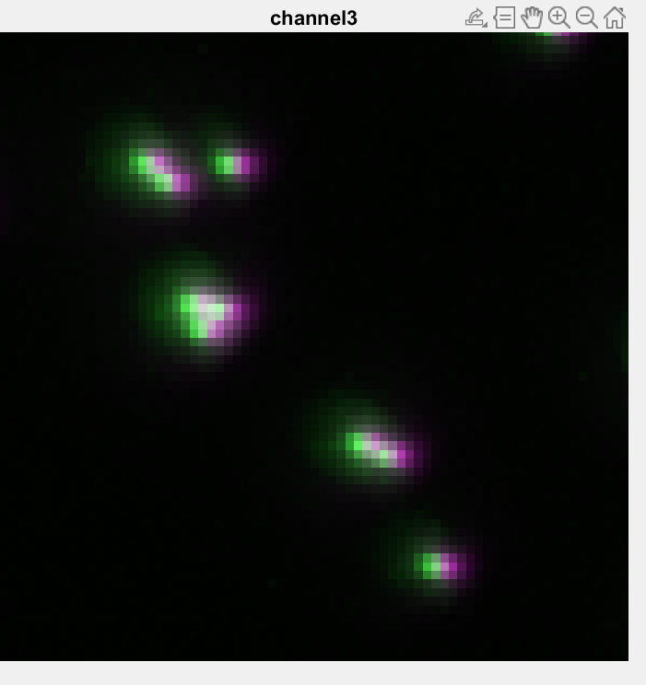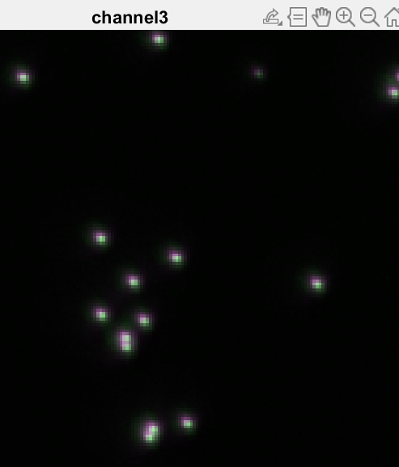
Left figure shows image from channel A overlaid on channel G, shift from changing imaging wavelength. Right figure shows corrected image after channel shift.
5. Calculate bleed-through and create channel profile
- Repeat step 2:
take 4 channel image of each chamber of calibration slide at optimal exposure time, make a max projection image of each channel. Combine them into image stack (G,T,A,C) and name it as MAX_img_stack.tif in each chamber folder (“G_chamber”, “T_chamber”, “A_chamber”, “C_chamber”).
- Run step3_calculate_bleedthrough_Aixin.m, this performs:
  - background subtraction
  - apply channel shift
  - find rolonies
  - calculate signal vector for rolonies
  - remove noise
  - scale by median signal intensity
  - Saves channel profile chprofile20x-microscopename-date.mat
All steps are included in script. Save your bleedthrough matrix for analysis pipeline.

6. Check if your calibration is working as you expect!
- Image gene sequences from real BARseq libraries over multiple gene cycles (ideally 7 for full gene calling).
- Run image registration pipeline
- Check registered images carefully for any systematic shifts in rolonies according to imaging channel. Check for remaining bleed through signal.

